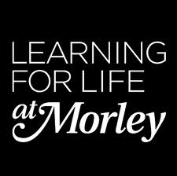

**Educate Out Prejudice Curriculum Pilot**

**Fast Track ESOL Entry 2 - Sandra Cumming**

**Contents:**

1. Lesson Plan (pp. 2 – 4)
2. Group Profile with Equality and Diversity Statement (pp. 5)
3. Resources (pp. 6 – 11)

The creation of this material by Morley College has been financed by the Skills Funding Agency Equality and Diversity Innovation Fund 2013/14.Copyright in this material is vested in the Crown but it is made freely available through an Open Government Licence. This licence enables you to use and adapt the material but you must attribute Morley College as the creator and include details of the licence. Full details of the licence are available at <http://www.nationalarchives.gov.uk/doc/open-government-licence/>

 **LESSON PLAN** **Essential Skills 2013-2014**

|  |  |  |  |  |  |
| --- | --- | --- | --- | --- | --- |
| **COURSE TITLE: Fast Track ESOL Entry 2**  **COURSE CODE: EEB010A** | | **TUTOR**  **Sandra Cumming** | **WEEK NO**  6 | **DATE OF LESSON**  11/2/14 | **NO. OF LEARNERS**  **13** |
| **LEARNING OUTCOMES**  (What the student will know or be able to demonstrate by the end of the session) | **By the end of the session students will be able to:**  1. Read a news article for gist and information.  2. Use dictionaries to acquire new vocabulary on protected characteristics.  3. Use new vocabulary in speaking about equalities and discrimination. | | | | |

|  |  |  |  |  |  |
| --- | --- | --- | --- | --- | --- |
| **TIME** | **PURPOSE** | **LEARNER AND TEACHER ACTIVITY** | **DIFFERENTIATION/**  **DIVERSITY\*** | **ASSESSMENT OF LEARNING** | **RESOURCES** |
| 10.00 | Revision – past simple, asking questions | Talk in pairs about what you did at the weekend – introduction activity to practice using past simple tense. Tutor writes examples of good questions on SMART board. | Encourage quieter learners to participate | Tutor observation | SMART board with questions |
| 10.15 | Promote citizenship | Introduce topic: **Discrimination: your rights**  – elicit meaning of *discrimination*, *sexism, racism, ageism*  Pre-teach vocab – transsexual, pregnant, sexual orientation, to fire someone  Elicit which words learners know, learners use mobile phones, dictionaries to look up new words – check whole class using photos from the internet of transvestites, transgender people, a pregnant woman, same-sex marriages, people with disabilities  Practice pronunciation with drilling – Tutor pronounces words and the students repeat them back | Many learners are working in low-paid, zero-contract, casual jobs as cleaners so employment law is useful for them  Some learners have poor pronunciation skills |  | Internet  Dictionaries  Mobile phones |
| 10.25 | 1, 2 | **Reading activity 1** – adapted from UK Government website by tutor –  **Types of discrimination:**  ‘protected characteristics’  Work in pairs - Use dictionaries/mobiles to look up words: discrimination, protected, legal, illegal – check whole class  Answer **true/false** questions about UK law on discrimination | Some learners have experienced discrimination from landlords due to nationality | Tutor observation  Able to answer True/False questions correctly | [www.gov.uk](http://www.gov.uk)  Internet Dictionaries  Mobile phones  Tutor’s own hand-out |
| 11.00 | 3 | Discuss in small groups: Does your country have the same laws?  Encourage learners to use new vocabulary  Report back to class | Tutor assist with pronunciation as necessary | Tutor observation |  |
| 11.45 | 1, 2, 3 | **Reading activity 2**  Newspaper article (slightly adapted) about B and B owners who refused to let a same-sex couple share a room.  Answer questions individually – check answers in pairs  Discuss Question 10 – Did the judge make the right decision? Tell another pair your answer  Whole class discussion | Tutor monitor and assist weaker readers as necessary |  | *Mail Online* 18/10/12  Dictionaries, Mobile phones |
| 12.20 |  | Complete feedback form |  |  | Tutor’s own hand-out |

|  |
| --- |
| **EVALUATION OF LESSON (Were the learning outcomes achieved? What was successful? What could be improved? Is there anything that needs to be carried over to the next session?)**  This was a stand-alone lesson but we have been working on reading comprehension, pronunciation and improving vocabulary.  All students were able to understand the meaning of discrimination and got most of the true/false questions correct. The word discrimination is the same in Spanish and French so that helped. According to their feedback, it seems they appreciated being made aware of the discrimination laws in this country.  The class enjoyed the discussion and offered many examples of discrimination in their countries as well as some in the UK (mostly to do with housing). Some students thought landlords were reluctant to let property to them because of the language difficulties, but others thought it was due to being Colombian and perceived as possibly criminal.  With the article about B and B’s we got a bit side-lined because no one really knew what they were, and got quite excited when they did know, but this could be a useful and enjoyable lesson for the future – Holidays in the UK.  No one in the class expressed any feelings of discomfort or opposition to any of the ‘protected categories’.  They were keen to practice the pronunciation of all new words.  In future I would include a new vocabulary chart for them to fill in and learn. |

The creation of this material by Morley College has been financed by the Skills Funding Agency Equality and Diversity Innovation Fund 2013/14.Copyright in this material

is vested in the Crown but it is made freely available through an Open Government Licence. This licence enables you to use and adapt the material but you must attribute

Morley College as the creator and include details of the licence. Full details of the licence are available at <http://www.nationalarchives.gov.uk/doc/open-government-licence/>

 **Essential Skills 2013-2014**

**Group Profile with Equality and Diversity Statement**

|  |  |  |  |
| --- | --- | --- | --- |
| Course Title: Fast Track ESOL Entry 2 | | | |
| Course Code: | EEB010A | Level | Entry 2 |
| Number on register | 16 | Tutor: Sandra Cumming | |
| **Comments on the students, class dynamics**  There are 16 people in the class ages ranging from 27 to late 50’s. There are 12 women and 4 men. Eleven are Spanish speakers, 1 Russian, 1 Arabic/Farsi, 1 Polish, 1 Portuguese/Italian, 1 French. The class is lively and friendly and learners are happy to support each other and work together. x, x and x tend to dominate as very confident speakers although often inaccurate. x, x, x, x, x all quite unconfident and quiet. xx(Russian speaker) has been in the UK for 7 years – much longer than anyone else but her pronunciation is very weak. Most have been here 2 years or less. x has been here 5 years, x and x 3 years. Eight work as cleaners, 1 hairdresser, 1 pastry chef (working very long hours), 1 professional musician (now earning a living as a cleaner). Their work is hard and tiring, starting very early and/or finishing very late, so they are often tired in class. | | | |
| **Differentiation for this group based on the above**  Need to ensure class is not dominated by more assertive learners like x, x and x. Work to improve confidence in less confident, quieter learners.  Give more assistance to weaker learners – x, x, x.  Recognise some learners may be very tired which may affect progress.  Work to improve pronunciation where necessary – x, x, x. | | | |
| **Equality and Diversity and Safeguarding**  Ensure Spanish speakers speak English in class so as not exclude minority non-Spanish speakers.  Include topics of interest such as music and cooking.  Utilise students’ areas of expertise – music, digital media, cooking.  Ensure no one is feeling out of place, excluded or not respected in any way. Use different pairings/ small group activities so they all feel comfortable with each other. | | | |



**Embedding LGBT –** **Fast Track ESOL Entry 2: Resources.**

1. **Protected Characteristics Reading Activity and Worksheet (pp.7-8).**

**Online Source: GOV UK (2014) *Discrimination: your rights*, [Online], Available:** [**https://www.gov.uk/discrimination-your-rights**](https://www.gov.uk/discrimination-your-rights) **[18 June 2014].**

1. **Mail Online Article Reading Activity and Worksheet (pp.9-10).**

**Online Source: Webb,S. (2012) *Christian B&B owners who refused bed to gay couple ordered to pay £3,000 in compensation*, [Online], Available:** [**http://www.dailymail.co.uk/news/article-2219594/Christian-B-amp-B-owners-refused-bed-gay-couple-ordered-pay-3-000-compensation.html**](http://www.dailymail.co.uk/news/article-2219594/Christian-B-amp-B-owners-refused-bed-gay-couple-ordered-pay-3-000-compensation.html) **[18 June 2014].**

1. **Evaluation form Reading Activity (pp.11).**



The creation of this material by Morley College has been financed by the Skills Funding Agency Equality and Diversity Innovation Fund 2013/14.Copyright in this material is vested in the Crown but it is made freely available through an Open Government Licence. This licence enables you to use and adapt the material but you must attribute Morley College as the creator and include details of the licence. Full details of the licence are available at <http://www.nationalarchives.gov.uk/doc/open-government-licence/>

The creation of this material by Morley College has been financed by the Skills Funding Agency Equality and Diversity Innovation Fund 2013/14.Copyright in this material is vested in the Crown but it is made freely available through an Open Government Licence. This licence enables you to use and adapt the material but you must attribute Morley College as the creator and include details of the licence. Full details of the licence are available at <http://www.nationalarchives.gov.uk/doc/open-government-licence/>

**Discrimination: Your rights** [**www.gov.uk**](http://www.gov.uk)(adapted)

**1. Types of discrimination**

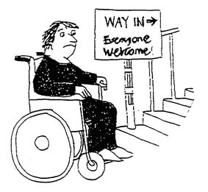It is against the law ***to discriminate*** against anyone because of:

* age
* being or becoming a transsexual person
* being married or in a civil partnership
* being [pregnant](https://www.gov.uk/working-when-pregnant-your-rights) or having a child
* [disability](https://www.gov.uk/definition-of-disability-under-equality-act-2010)
* race including colour, nationality, ethnic or national origin
* religion, belief or lack of religion/belief
* 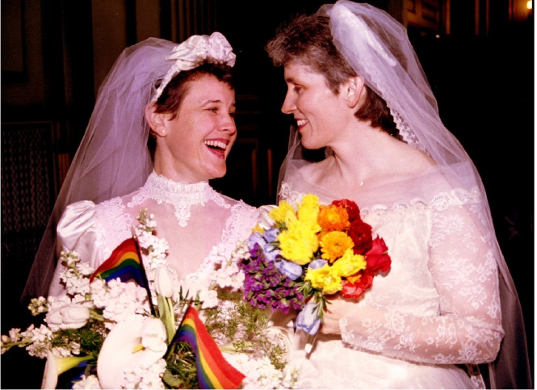sex
* sexual orientation

These are called ‘protected characteristics’.

You’re protected from discrimination in these situations:

* at work
* in education
* as a consumer
* when buying or renting property

Everyone is ***legally protected*** from discrimination by the [**Equality Act 2010.**](http://www.legislation.gov.uk/ukpga/2010/15/contents)



Signs like this one were often displayed by landlords before the Race Relations Act of 1976 and the Equality Act of 2010.

**Use a dictionary, or your mobile, to look up the meaning of these words. Write the meaning in your language and in English.**

discrimination: ………………………………………………………………………..…...

……………………………………………………………………………………………..……

protected: …………………………………………………………………………….…….

legal: ………………………………………………………………………………………….

What is the opposite of ***legal***? ……………………………………………………

**Answer the following questions:**

1. It’s legal for a landlord to say you can’t have the flat because you are black.

**true / false**

2. It’s illegal for an employer to fire you because you are pregnant.

**true / false**

3. It’s legal for a football club to fire a player because he’s gay. **true / false**

3. It’s legal for an employer to fire you because you are always late for work.

**true / false**

4. It’s illegal for a college to say you can’t study English because you suffer from epilepsy.

**true / false**

5. It’s legal for a hotel receptionist to tell a same-sex couple they can’t have a double room.

**true / false**

6. It’s illegal for a business to say you must be aged between 25 and 35, and female, to apply for the job.

**true / false**

7. It’s legal for two men to marry each other.

**true / false**

**Mail**Online 18 October 2012

**Christian B and B owners refuse bed to gay couple**

A devout Christian bed and breakfast owner who refused a bed to a gay couple was today ordered to pay them more than £3000 in compensation.

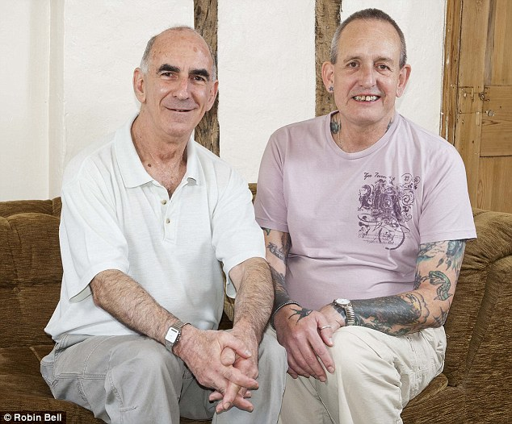Michael Black, 64, and his partner John Morgan, 59, began a legal battle soon after they were told they could not sleep together at the £75-a-night Swiss Bed and Breakfast in Cookham, Berkshire in March 2010.



Owner Susanne Wilkinson told a court she was serious about her Christian beliefs and had also stopped unmarried heterosexual couples from sharing a double bed.

But a judge at Reading County Court ordered her to pay £3,600 in damages for discriminating directly against the couple, who have been together for eight years.

Michael and John’s claim was made under the Equality Act (Sexual Orientation) Regulations 2007. They argued that it was unlawful for a person providing services to the public to discriminate on the grounds of sexual orientation.

*************************

1. This text is a

* letter
* advert
* newspaper article

2. What is the text about?

* Christian beliefs
* discrimination
* holidays

3. What is a B and B?

………………………………………………………………………………………………..

4. Who owns the B and B?

* Michael Black
* John Morgan
* Susanne Wilkinson

5. What’s the name of the B and B?

………………………………………………………………………………………………..

6. Where is the B and B?

……………………………………………………………………………………………….

7. Who wanted to stay in the B and B?

…………………………………………………………………………………………………

8. The owner was happy for the couple have a room in the B and B.

**true / false**

9. The judge said the owner of the B and B made the wrong decision.

**true / false**

10. Do you think the judge was right? Why?

…………………………………………………………………………………………………

………………………………………………………………………………………………....

What do you think about today’s English lesson?

  

I enjoyed it. I really enjoyed it. It was great.

I didn’t enjoy it because ……………………………….………………………………….

I understand what **discrimination** means. **yes / no / maybe**

In the UK it’s legal for an employer to say you can’t have the job because you’re too old.

**true / false**

It’s illegal for a business to fire a woman because she’s pregnant.

**true / false**

It’s OK for a landlord to say you can’t have a flat because you’re from Colombia.

**true / false**

Any other comments about today’s lesson?

**……………………………………………………………………………………………………………………………………………………………………………………………………………………………………………………………………………………………………………………………………………………**